

**E-PROJECT**

**CurrenSee**

**Group Members Submitted To**

**1-** **BASHARAT eprojects@aptechfze.ae**

**Student1359418**

**2-** **MUHAMMAD MAAZ PROJECT INSTRUCTOR**

### Student1345844 Sir Abdul Rahim

**3-** **ANAS AHMED**

**Student1358297 CURRICULUM CODE**

**OV-ACCP Prime-7062-ACE**

**TABLE OF CONTENT**

**ACKNOWLEGDMENT .................................................. 3**

**PROJECT CERTIFICATION ............................................ 4**

**INTRODUCTION …………………....................................... 5**

**REQUIRMENT SPECIFICATION ..................................... 5**

1. **HARDWARE REQUIRMENT................................... 6**
2. **SOFTWARE REQUIRMEN...................................... 6**

**PROJECT DURATION .................................................... 7**

**TASK SHEET.................................................................. 8**

**SNAPSHOT ................................................................... 9**

**ACKNOWLEDGEMENT**

We are thankful to Almighty, **ALLAH** that by his grace we have been successful. We are presenting our E-project in your hands. We have tried our best to take all relevant important topics in consideration so that this project may become comprehensive and we would like to thank our very supportive Faculty Member Sir, Irfan Ahmed.

This is our **Second Semester E**-project. We have tried our best and struggled for a better results to come. This project has been developed in **Sublime Text.** We choose to make webpage for **Arts** as a project. We find easy to do coding in **Sublime Text.**

We earnestly hope that this project will provide all the necessarily information required for the user to fulfill their inspiration. However suggestions for improvement of the project will be thankfully received and acknowledge.

**E-PROJECT**

**CETIFICATION**

**This Is to Certify That,**

**M.Maaz, Basharat and Anas**

**Has Successfully Designed and Developed**

**eProject**



**“CurrenSee”**

**Date of Issue:**

**20-Oct-2022**

eProject

**INTRODUCTION**

The thirst for learning, upgrading technical skills and applying the concepts in real life environment at a fast pace is what the industry demands from IT professionals today. However busy work schedules, far-flung locations, unavailability of convenient time-slots pose as major barriers when it comes to applying the concepts into realism. And hence the need to look out for alternative means of implementation in the form of laddered approach.

The above truly pose as constraints especially for our students too! With their busy schedules, it is indeed difficult for our students to keep up with the genuine and constant need for integrated application which can be seen live especially so in the field of IT education where technology can change on the spur of a moment. *Well, technology does come to our rescue at such times!!*

Keeping the above in mind and in tune with our constant endeavour to use Technology in our training model, we at Aptech have thought of revolutionizing the way our students learn and implement the concepts using tools themselves by providing a *live and synchronous eProject learning environment!*

**So what is this eProject?**

eProject is a step-by-step learning environment that closely simulates the classroom and Lab based learning environment into actual implementation. It is a project implementation at your fingertips!! An electronic, live juncture on the machine that allows you to

* Practice step by step i.e. laddered approach.
* Build a larger more robust application.
* Usage of certain utilities in applications designed by user.
* Single program to unified code leading to a complete application.
* Learn implementation of concepts in a phased manner.
* Enhance skills and add value.
* Work on real life projects.
* Give a real life scenario and help to create applications more complicated and useful.
* Mentoring through email support.

**REQUIRMENT SPECIFICATION**

**Hardware**

* A minimum computer system that will help you access all the tools in the courses is a Pentium 166 or better
* 64 Megabytes of RAM or better

**Software**

* Android Studio (For Flutter)
* Visual Studio (for Php)

**PROJECT DURATION**

* **ANALYSIS** 2 days
* **DESIGN** 4 days
* **DEVELOPMENT** 11 days
* **TESTING** 2 days
* **DOCUMENTATION** 1 days

**TASK SHEET**

|  |  |  |  |  |  |
| --- | --- | --- | --- | --- | --- |
| ***No*** | ***Task*** | ***Actual Start Date*** | ***Actual Days*** | ***Team Mate Name*** | ***Status*** |
| ***1.*** | ***Analysis*** | ***26-Oct-2022*** | ***2*** | ***BASHARAT***  ***MUHAMMAD MAAZ***  ***ANAS*** |  |
| ***2.*** | ***Design*** | ***29-Oct -2022*** | ***4*** | ***BASHARAT***  ***MUHAMMAD MAAZ***  ***ANAS*** |  |
| ***3.*** | ***Development*** | ***30-Oct -2022*** | ***11*** | ***BASHARAT***  ***MUHAMMAD MAAZ***  ***ANAS*** |  |
| ***4.*** | ***Testing*** | ***12-Nov -2022*** | ***2*** | ***BASHARAT***  ***MUHAMMAD MAAZ***  ***ANAS*** |  |
| ***5.*** | ***Documentation*** | ***14-Oct-2022*** | ***1*** | ***BASHARAT***  ***MUHAMMAD MAAZ***  ***ANAS*** |  |
| ***6.*** | ***Finalization*** | ***15-Oct-2022*** | ***1*** | ***BASHARAT***  ***MUHAMMAD MAAZ***  ***ANAS*** |  |

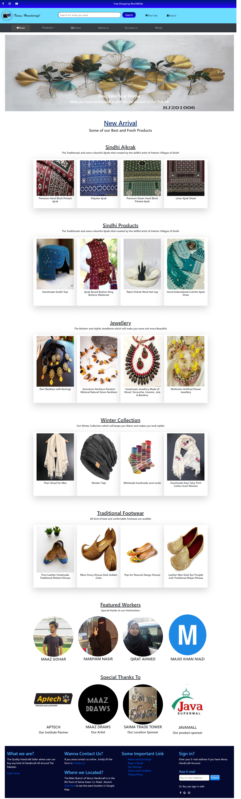**SNAP SHOTS**

**Login Page Register Page**

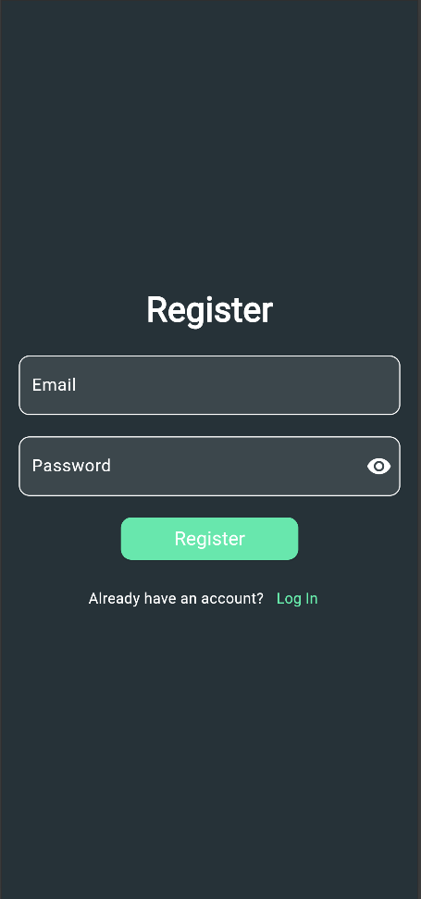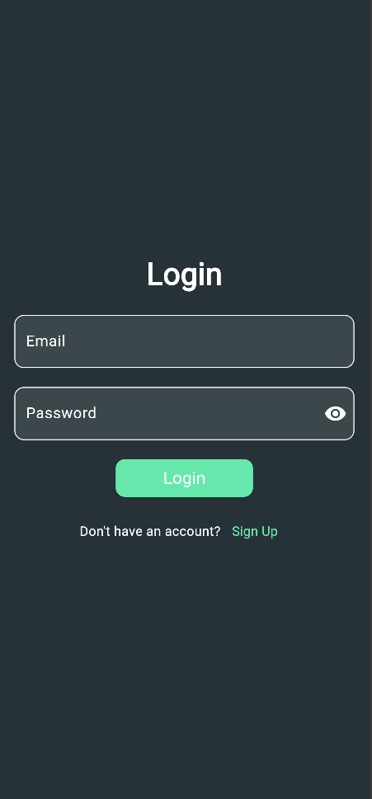

**Navigator Page Currency Converter Page**

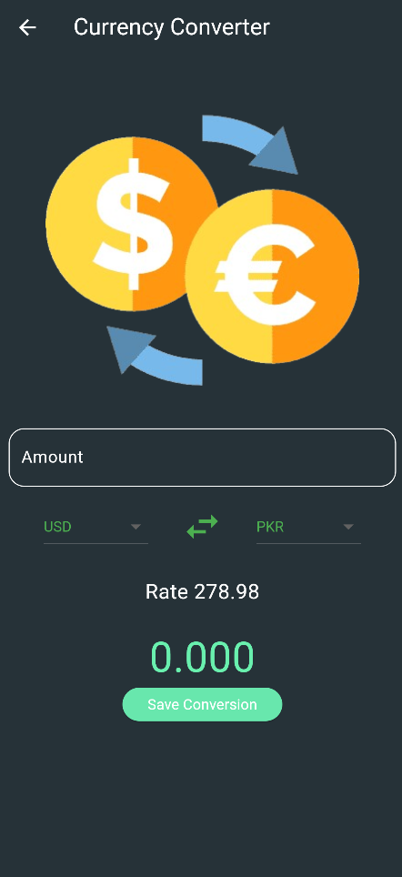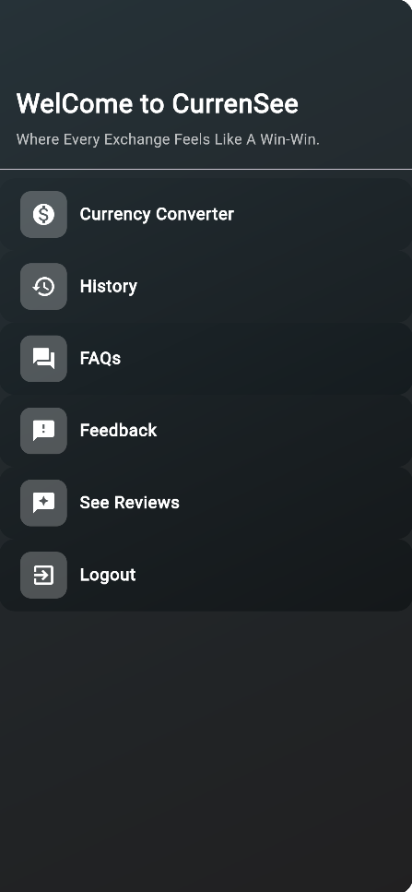

**History Page**

**FAQs Page**

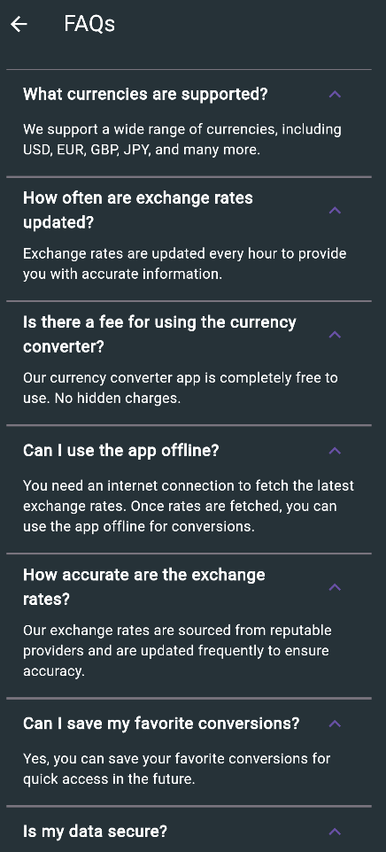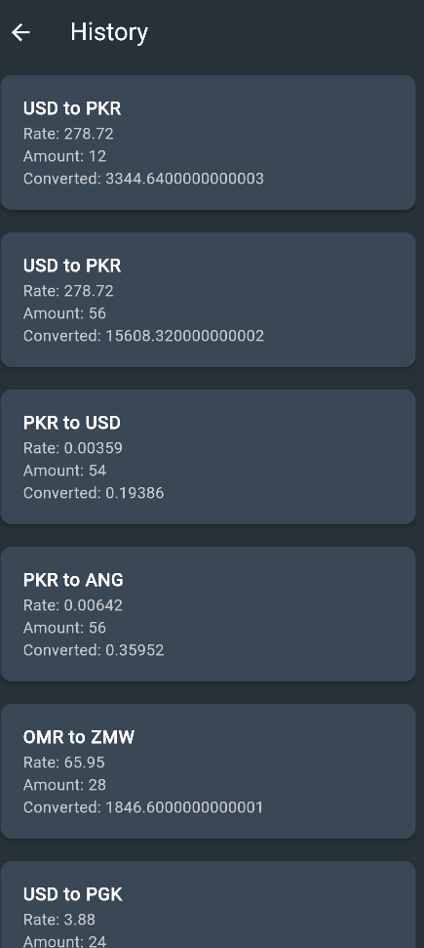

**Feedback Page Review Page**

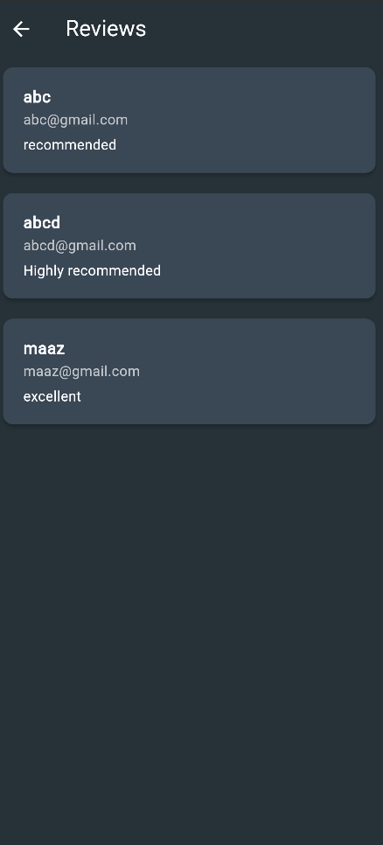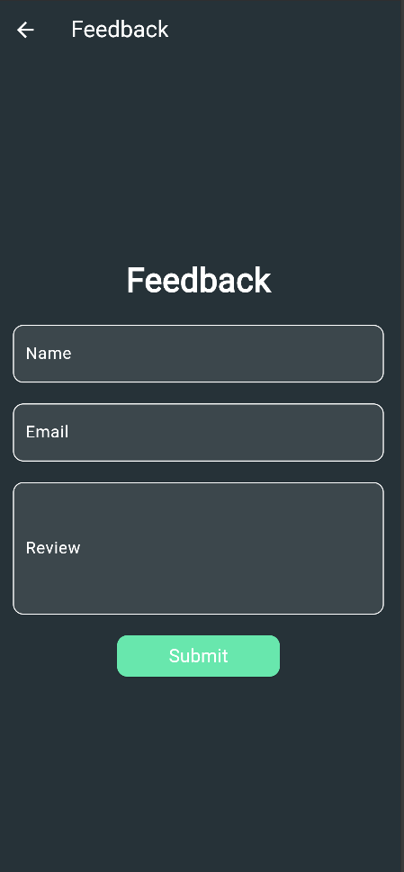

**PHP APIs Code Snaps:**

**DataBase Connection:**

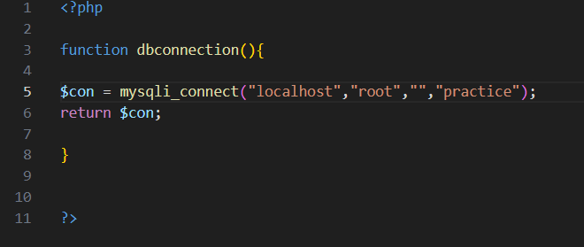

**Login Api:**

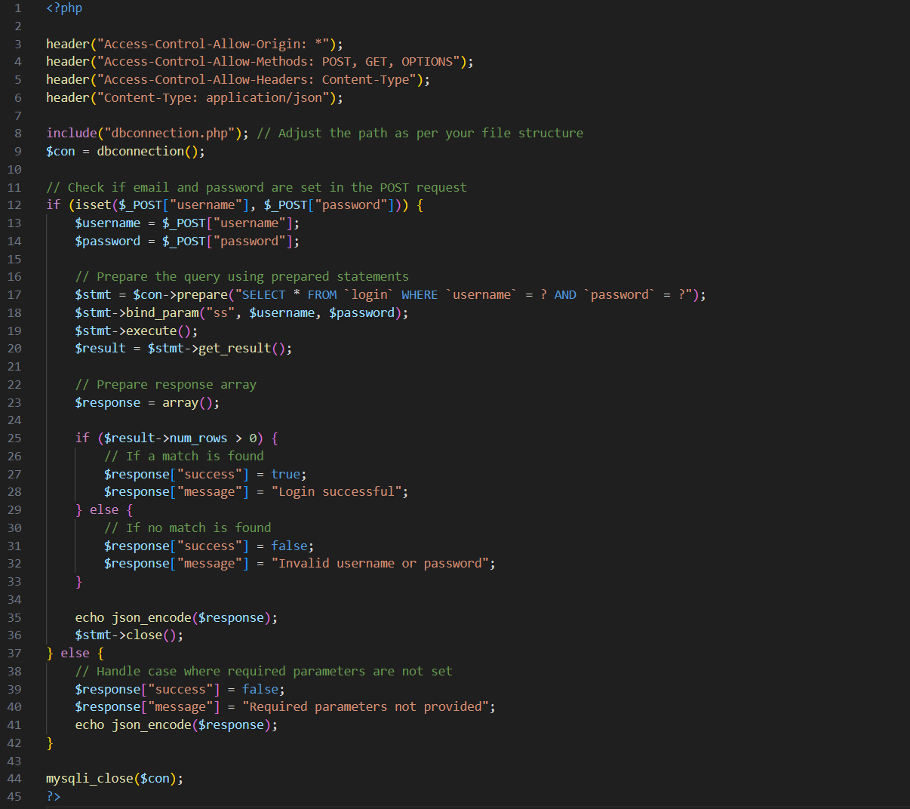

**Register Api:**

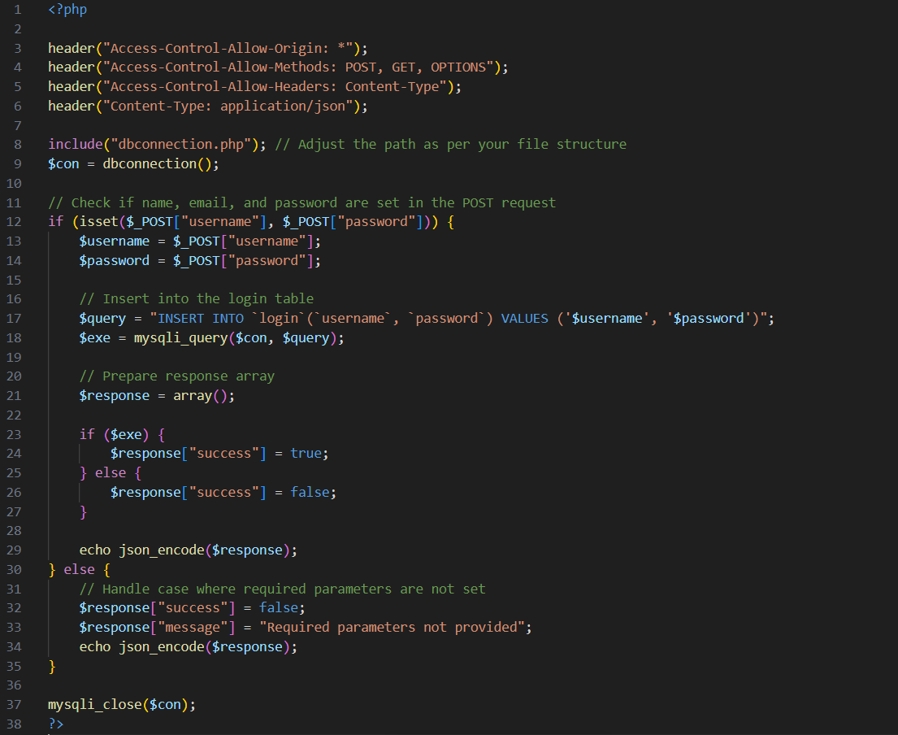

**Insert value of Currency:**

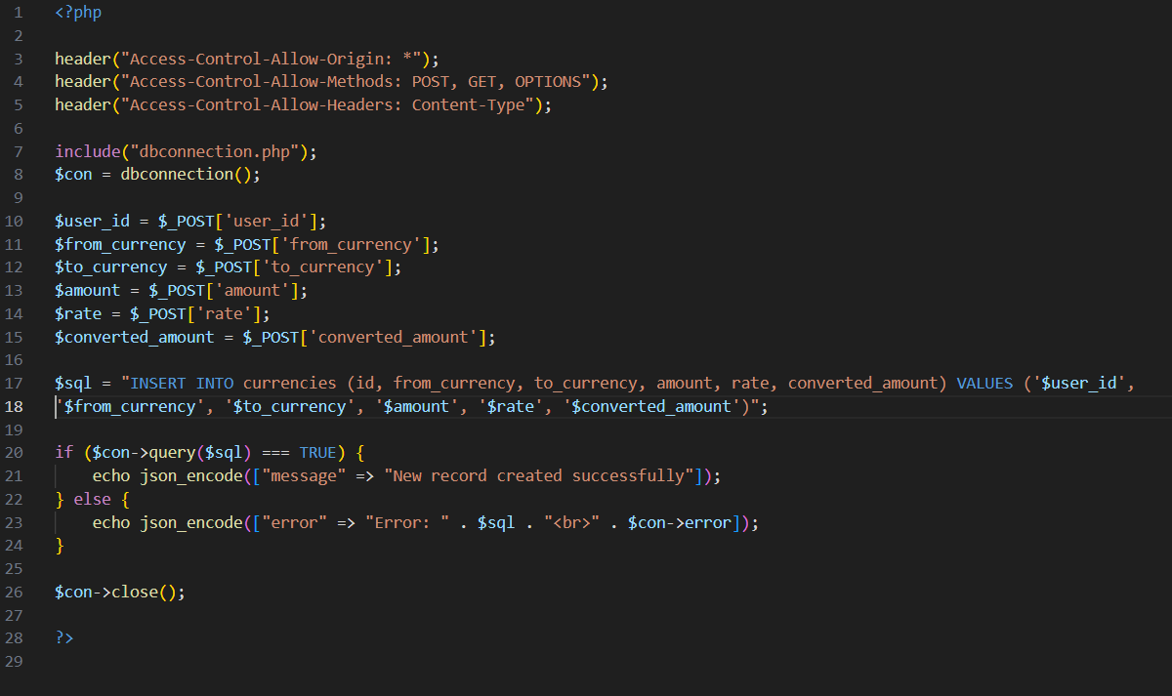

**History stores API:**

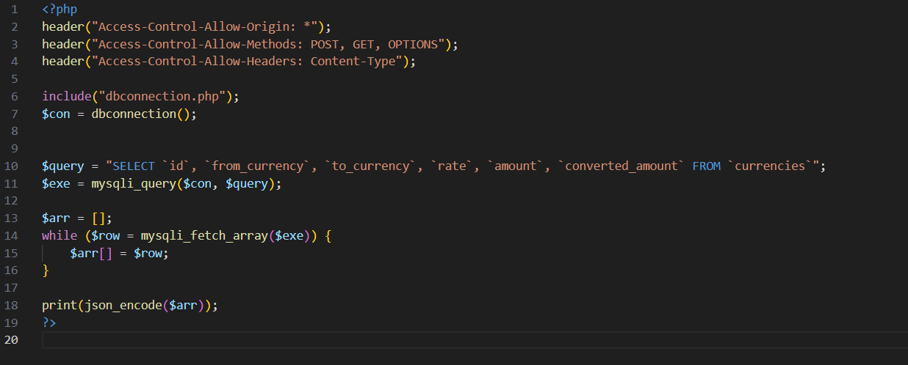

**Review API:**

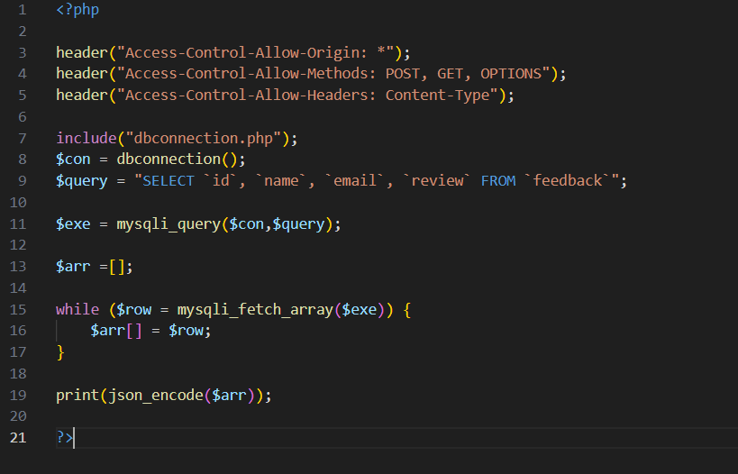

**The Developers is not required because we have already added comments in our website code so you will be able to understand our App structure easily and you can also edit and change any code with your choice.**

**Thanks**

**Best Regards,**